EDS ACTIVITY – 01

**NAME : GUNJAN BALAPURE**

**ROLL NO . CS7-49 PRN : 202401110027**

Search for kaggle dataset on google :

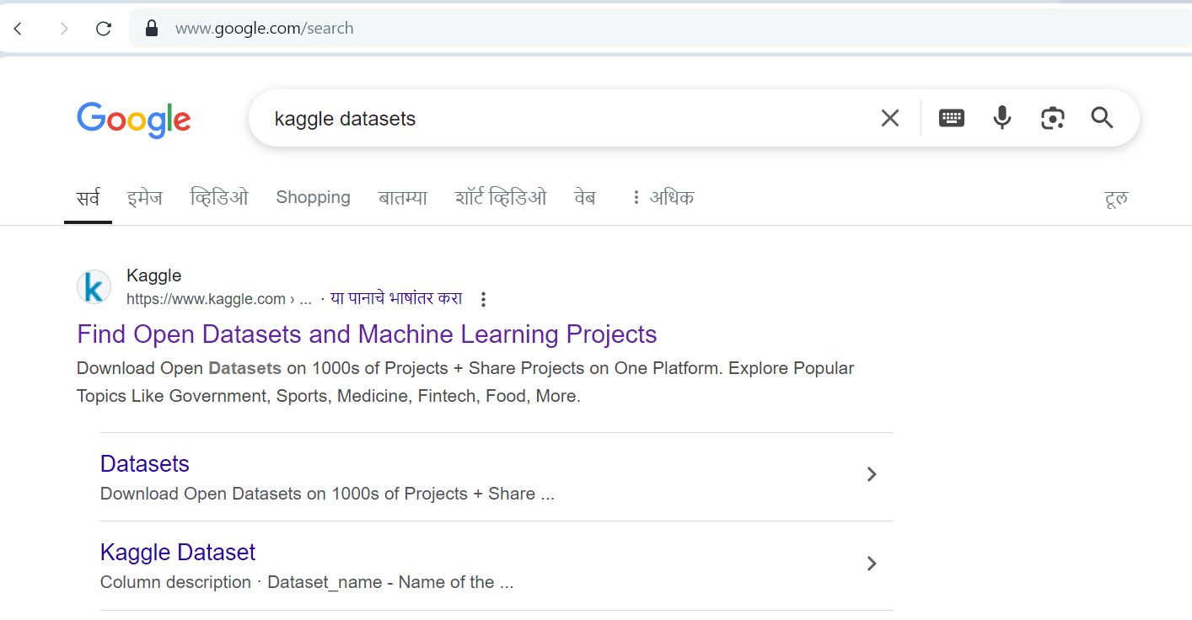

Search for given dataset :

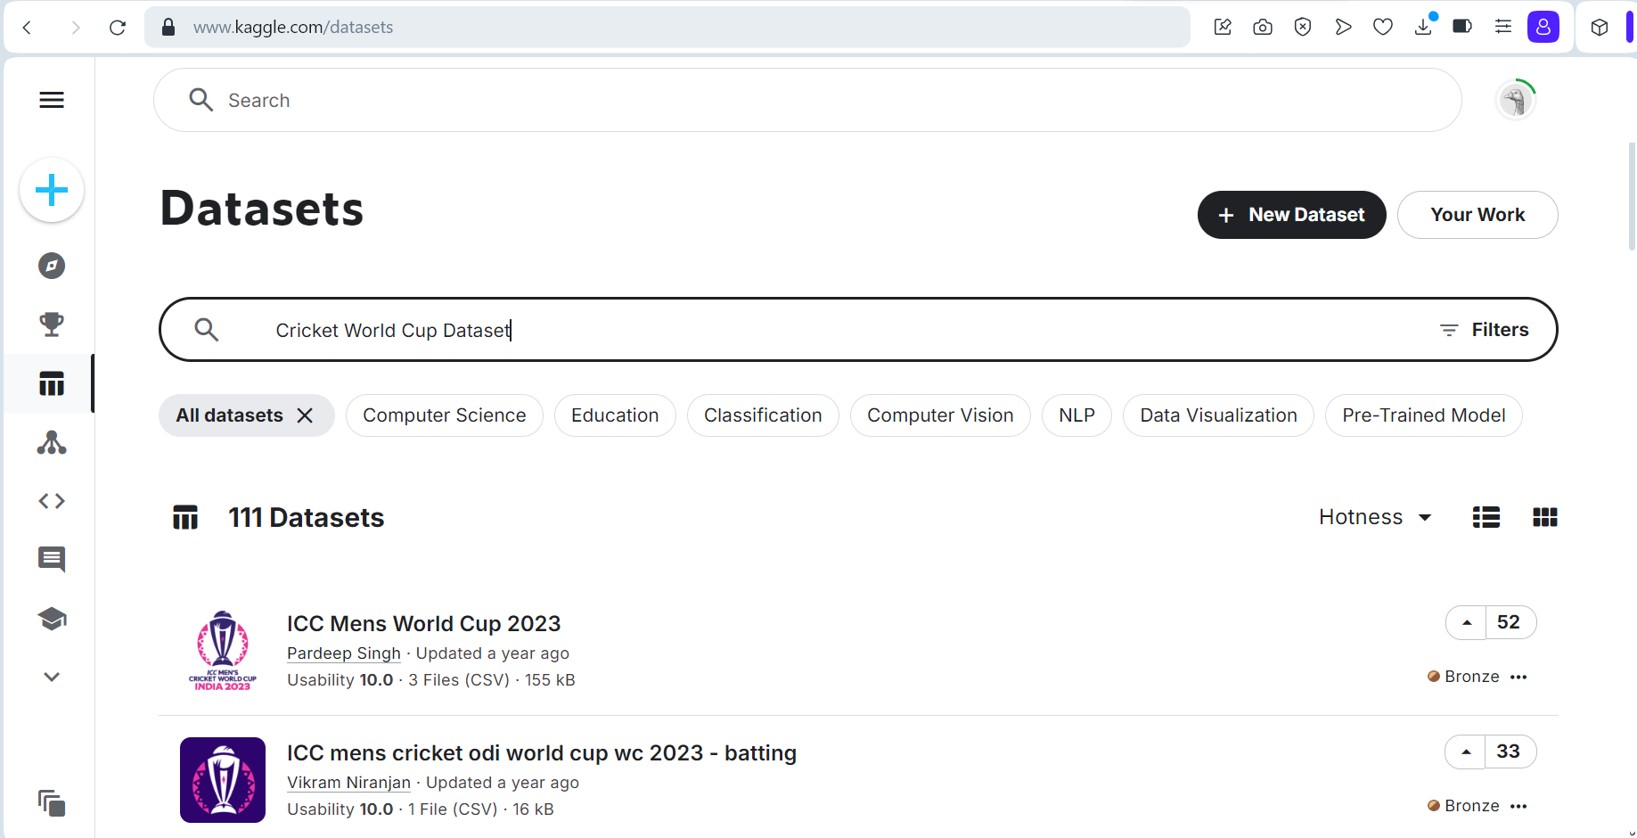

Download the most favourable dataset :

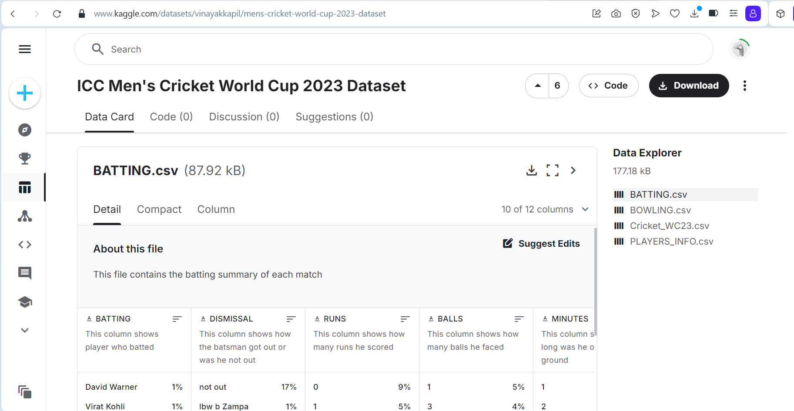

Whole Input Program :

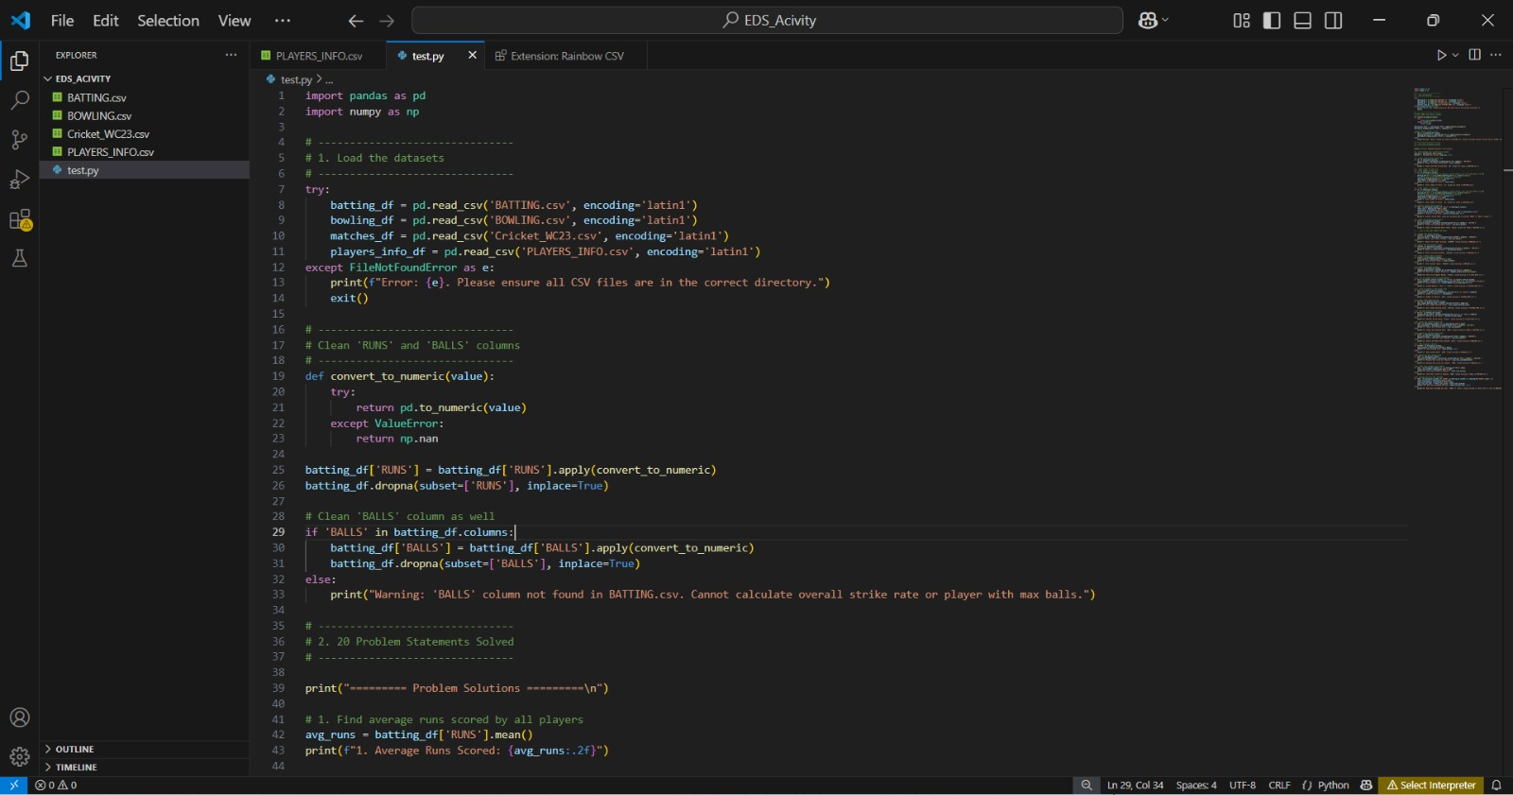

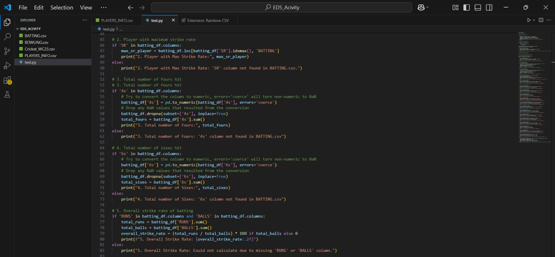

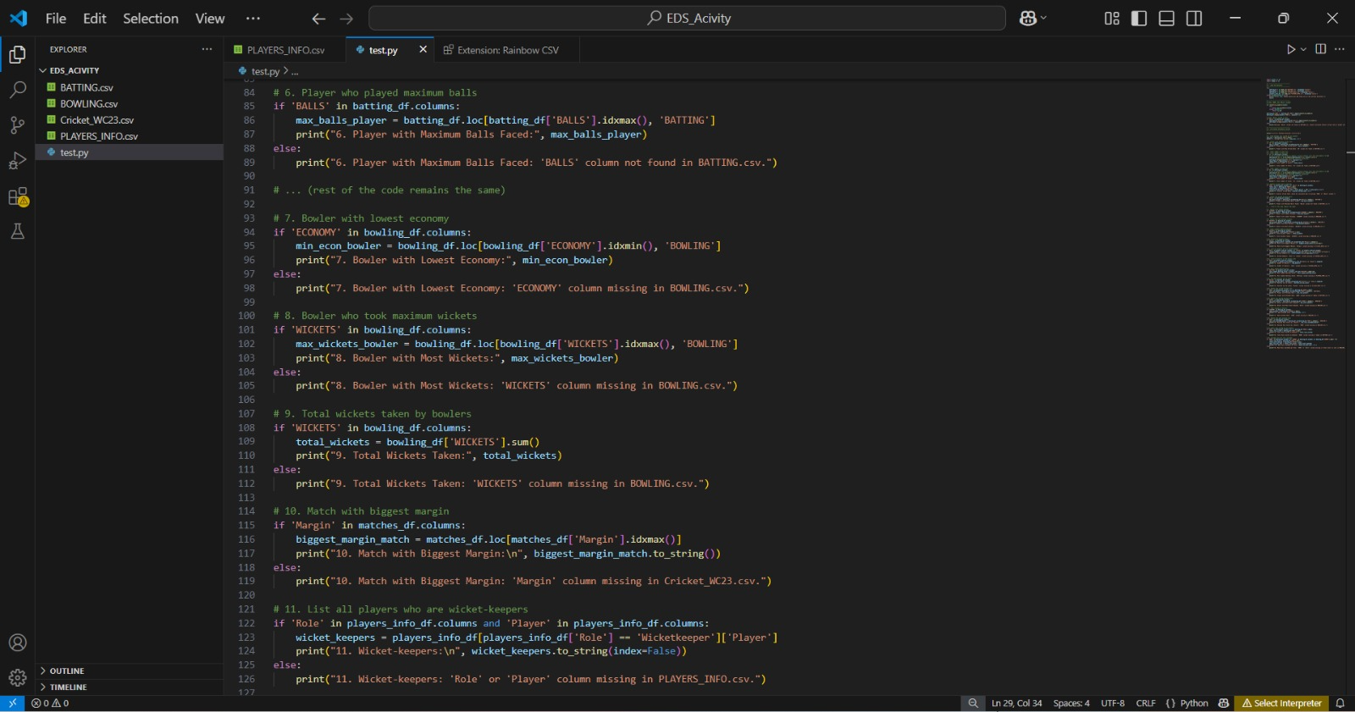

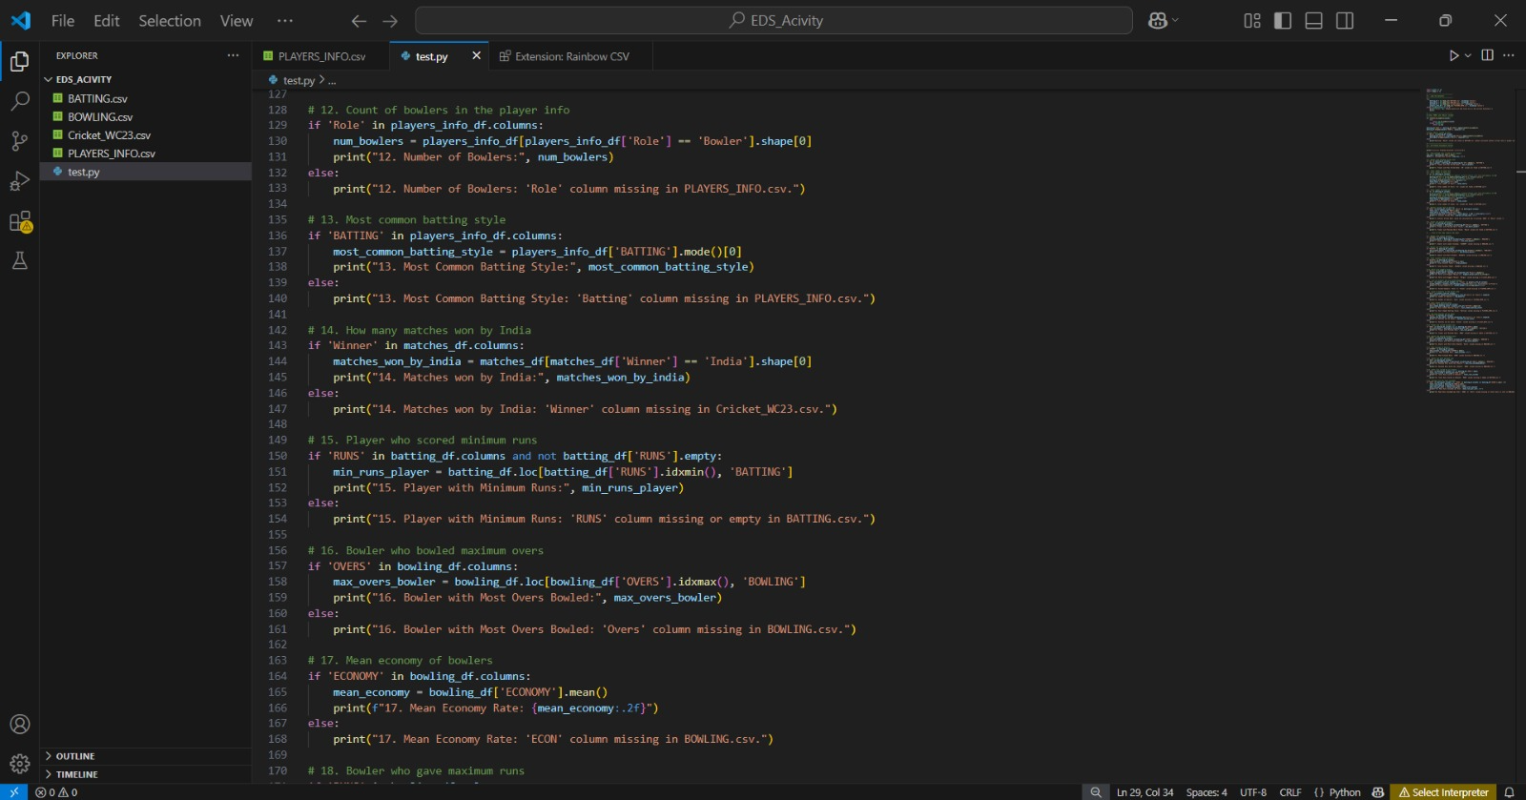

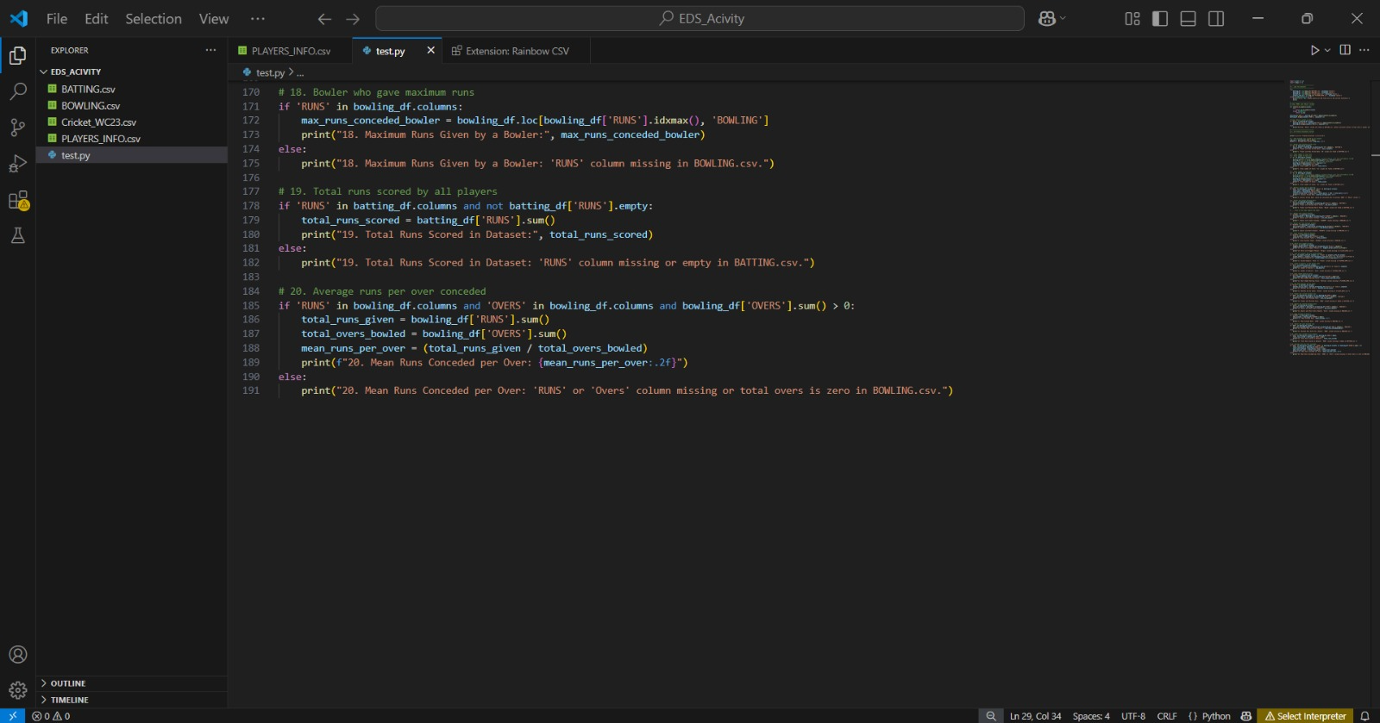

Output :

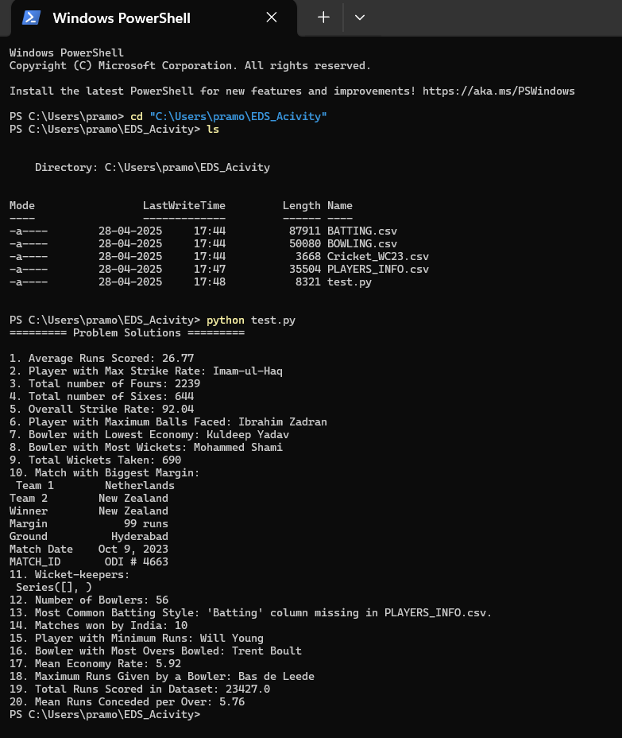

#problem 1

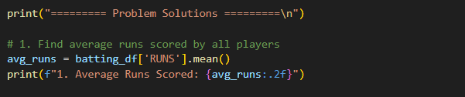



#problem 2

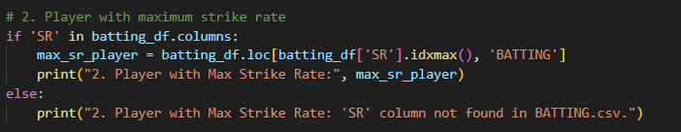



#problem 3

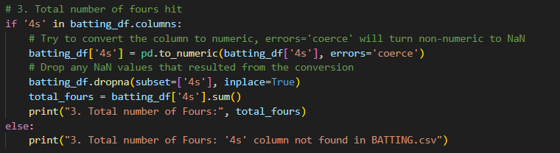



#problem 4

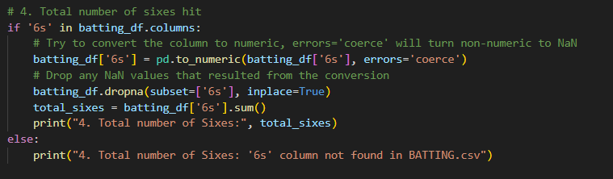



#problem 5

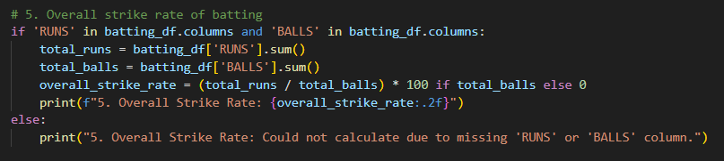



#problem 6

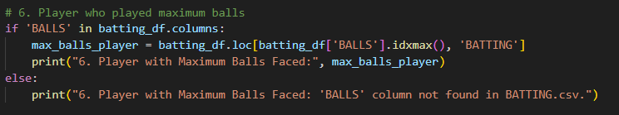



#problem 7

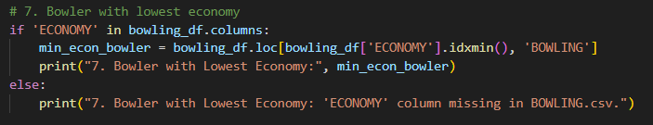



#problem 8

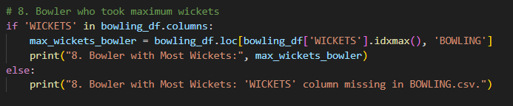



#problem 9

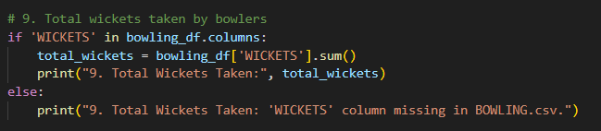



#problem 10

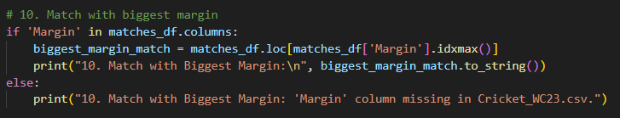

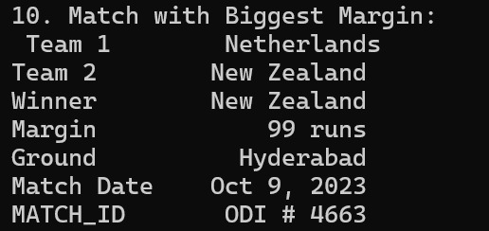

#problem 11

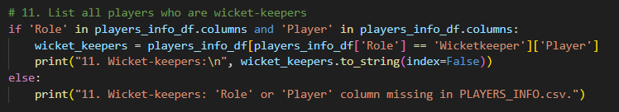

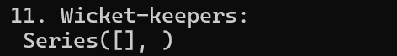

#problem 12

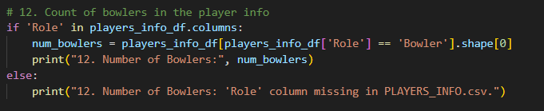



#problem 13

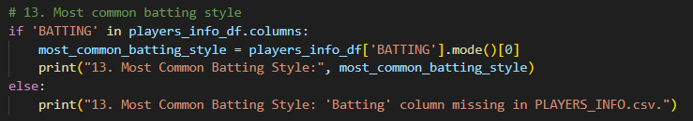



#problem 14

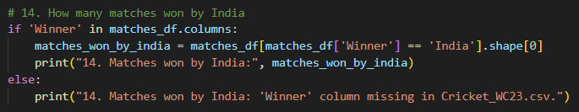



#problem 15

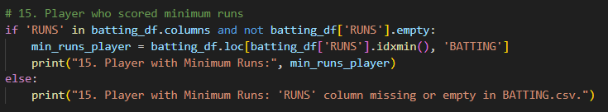



#problem 16

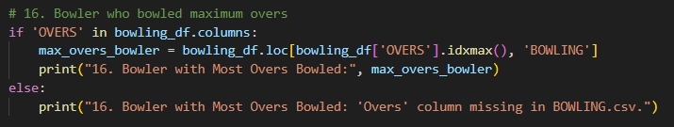



#problem 17

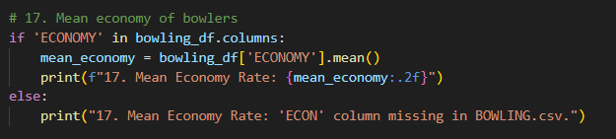



#problem 18

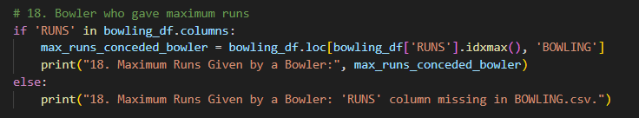



#problem 19

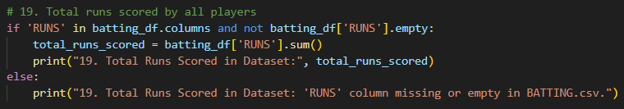



#problem 20

